ECE 4950 - Project 3
The Big Lebowski: Autonomous Bowling Robot

Team 19

Corey Golec, John Phillips,
Jacob Criswell, Avi Patel, Josue Morales-Sanchez

Date: 10/31/25

Executive Summary

This project involves implementing a hardware-in-the-loop (HIL) closed-loop position control system. Using a DC motor, a pointing arm is driven to indicate targets that are detected by a camera sensor system developed in the previous project. MATLAB/Simulink and an Arduino are used to connect the camera sensor system, which is capable of detecting the colored objects with the pointing arm to ‘select’ a target.
Overview of Hardware-in-the-Loop

Hardware-in-the-loop couples real controller and plant hardware into a simulation loop. Put simply, it means that certain components, such as the microcontroller and motor/driver, are physical, while other components and supervisory logic are simulated. It connects real-world components to a virtual model of the physical system. There are several similarities and differences between full simulations and hardware-in-the-loop simulations. One of the biggest differences is that an HIL loop can provide crucial information on several confounding variables when dealing with physical hardware, including important factors such as saturation, quantization, friction, and latencies. Because these values are non-ideal and can often hinder accurate results, it is essential to factor them in during the simulation process to create a properly functioning circuit. One of the strengths of the HIL method is that it mitigates potential risks down the road if a non-ideal component is not properly accounted for. It also provides faster iteration on controller gains and exposes integration issues early. Another upside is the cost, as it can reduce the need for physical prototypes, which can be expensive and hazardous. A downside to this is that the simulation and hardware components must be built with safety interlocks in order to ensure there is no mismatch between simulated and physical parts.
Hardware Documentation

In this project, we continued to use the camera and PVC mounting rig from project two. As discussed in project two, the resolution of the Logitech Brio 100 is 1920 x 1080 pixels and does act as an effective sensor. It is mounted on a PVC rig, which maintains the number of pixels for each shape consistently when reading in images. While the camera readings are highly dependent on lighting, this issue can be mitigated by implementing a controlled light source. For this project, we also added a DC motor, a motor controller, and an Arduino Mega 2560. The connected physical model is illustrated below in Figure 1.
As the rubric explicitly calls for the calculation of the camera resolution, the following are the results: Based on our image capture, the Brio 100 captures approximately 11 ⅛ inches by 7 ⅜ inches of the game board, indicating a resolution of about 25,273 pixels per square inch. At our rig height, usable FOV ≈ 11⅛″ × 7⅜″ → pixel density ≈ 1920×1080 ÷ (11.125×7.375) ≈ 25,273 px/in² → ≈ 44 px per ¾″ sticker diameter (sufficient for robust segmentation and centroiding).
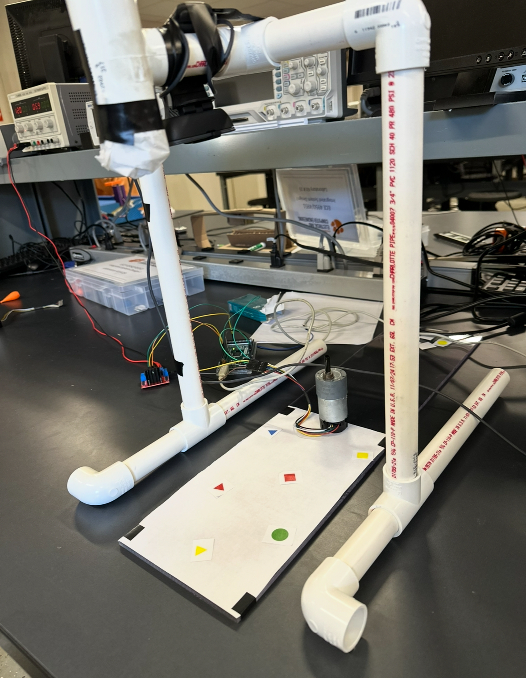
Figure 1. Complete physical model

Regarding the connections, the motor’s power terminals are connected to the output terminals on the motor driver. The motor’s hall sensor power and hall sensor ground are connected to the Arduino’s 5 volt and ground pins. The motor’s hall sensor A output is on pin 2 of the Arduino, and the hall sensor B output is on pin 3. On the motor driver, the A enable pin is connected to pin 5 of the Arduino. IN1 and IN2 on the motor driver are connected to pins 30 and 31. Finally, an external 12-volt source is connected to the 12-volt and ground terminals on the motor driver. Figure 2 below shows a connection diagram for the motor, motor driver, and Arduino.

Software Documentation

The software implementation for this project builds upon the code used in project two. The Image Processing Toolbox in MATLAB and a Brio 100 camera are used to read in background and foreground images, which then detect objects. The modified project two code used in this lab follows the following four functional stages:

- Background and Foreground Image Acquisition
- Background subtraction
- Noise Filtering
- Object Segmentation and Measurement

For this project, we add three more steps as follows:

- User Pin Selection
- Pin Angle Calculation
- Simulink Motor Call

Figure 3 below shows a flow diagram for the code
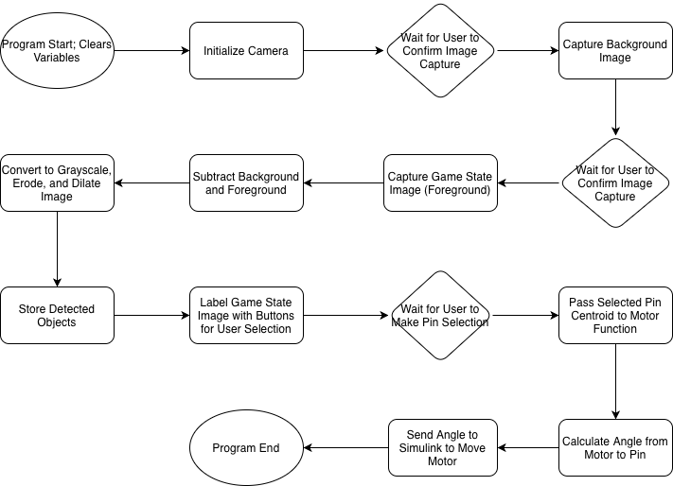
Figure 3. Main MATLAB script flow diagram

Essentially, after the image detection occurs, the program loops through every recognized object and adds it to an array of pin positions if it meets size thresholds. After finding all the pin positions, the program loops through all of the found positions and plots an interactive button onto the foreground image. When the user presses one of the buttons, a function is called with the specific centroid of the selected object. In this function, the angle between the centroid and a predefined origin point is calculated. The calculated angle is then used to set a parameter in the Simulink model, which causes the motor to rotate to the desired angle. After a set amount of time, the motor will then return to its original position. The Simulink motor model used in this project is shown below in Figure 4.

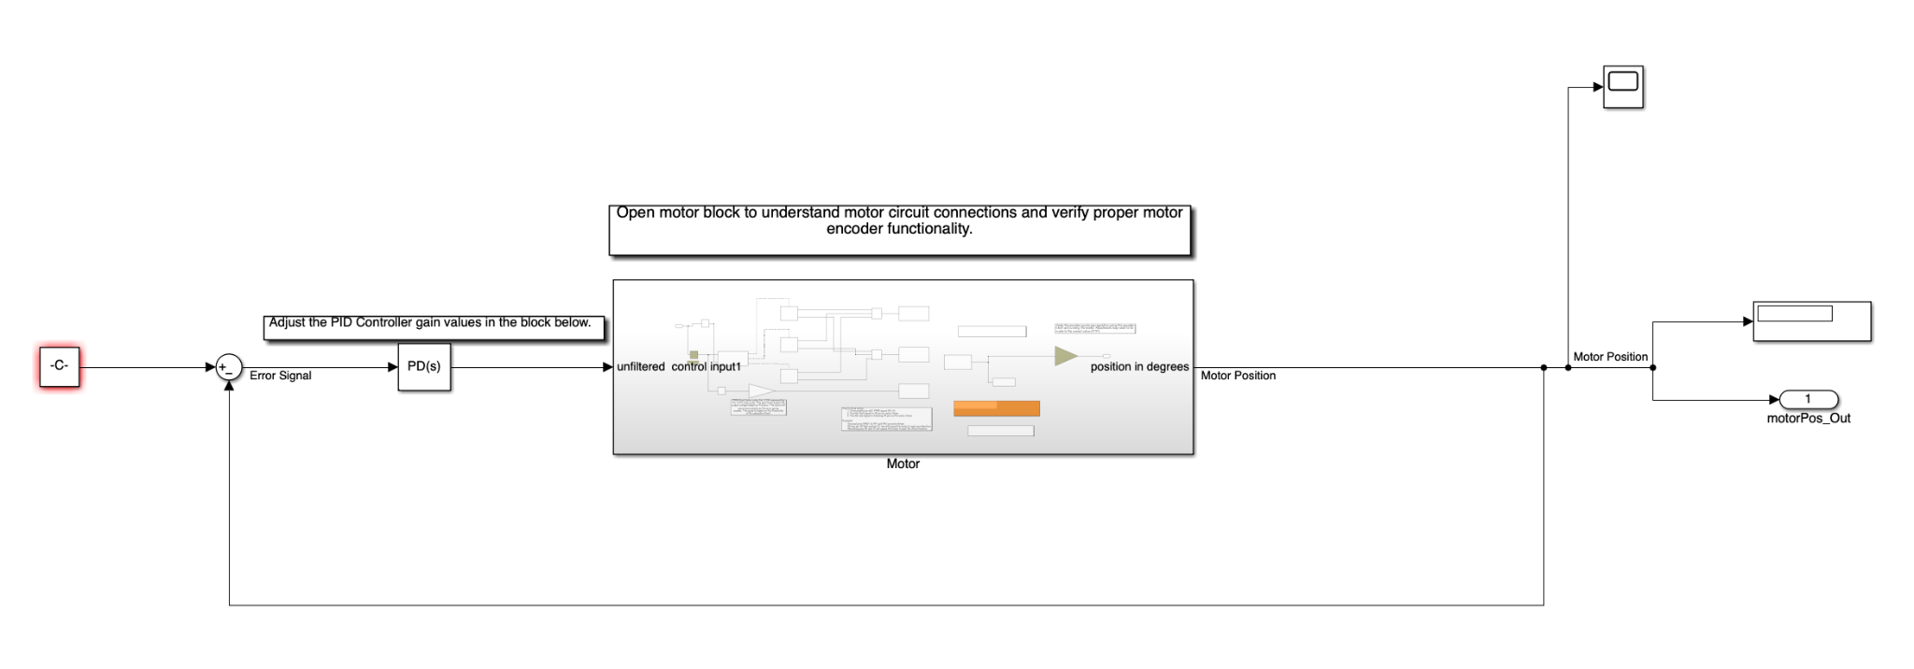
Figure 4. Simulink motor model

In addition to the structures developed in Project Two, there are also a couple more that are used throughout the program. The main structures used are listed in Table 1 below.

Table 1. Data structures used in the motor pointing program

Data Structure | Purpose
“gamestate” | Primary data structure holding data for the current state of the game. Holds original images and binaries. Also holds the location and color of all detected objects.
“STATS” | Region property structures save centroid, area bounded box and axis measurements for a detected object.
“pinPos” | Stores centroids for all detected objects from STATS that meet size thresholds.
“motorPosition” | Stores the x and y pixel coordinates for the motor's location. Set to be a constant percentage of the total camera length and width.

Overall, this program builds upon the previously developed image processing program to create a user-friendly and seamless interface that interacts with the user and Simulink. By overlaying buttons at the pin positions on top of the foreground image, the user can easily select their desired pin. By setting a constant in the Simulink model using a parameter setting function, we can continuously send angle updates to make the motor spin.
Motor Experiments Documentation
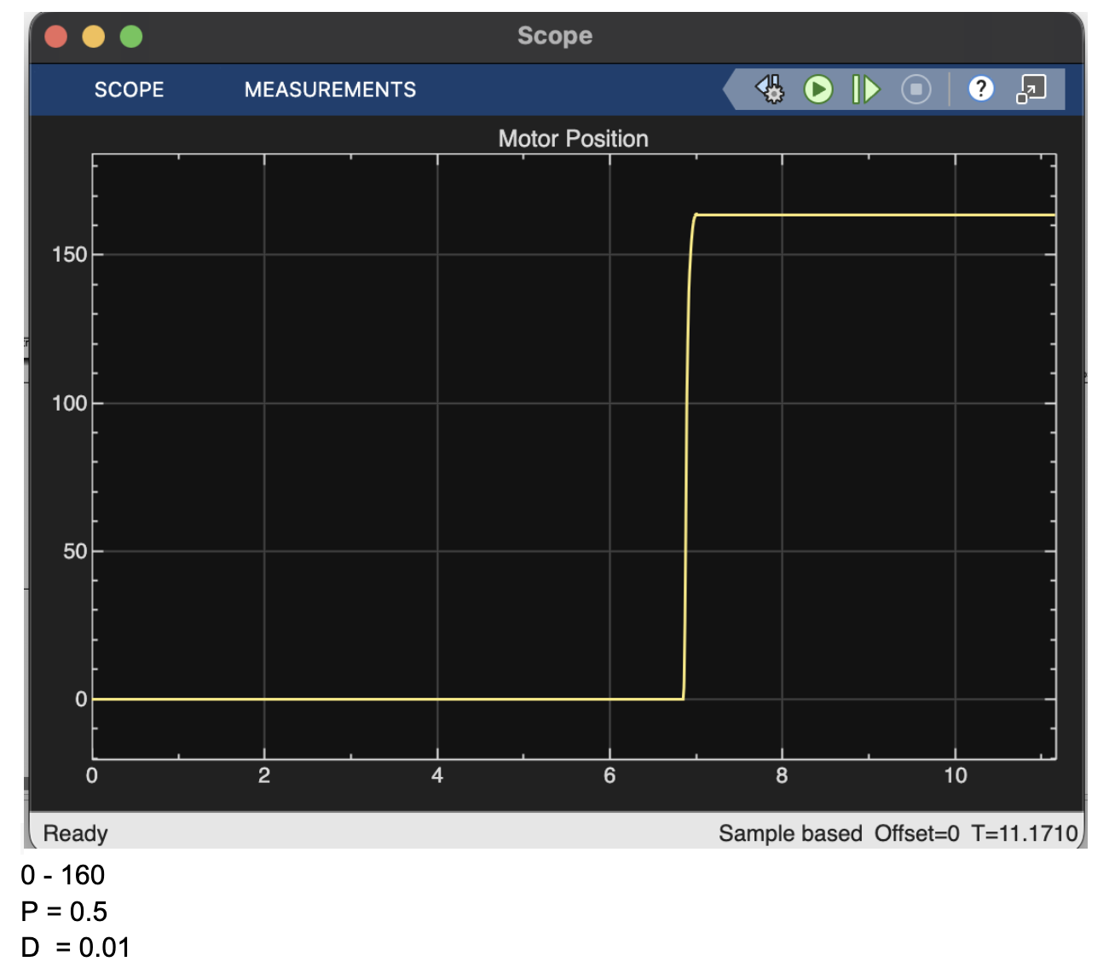
Figure 5: Motor angle response for Kp = 0.5 and Kd = 0.01
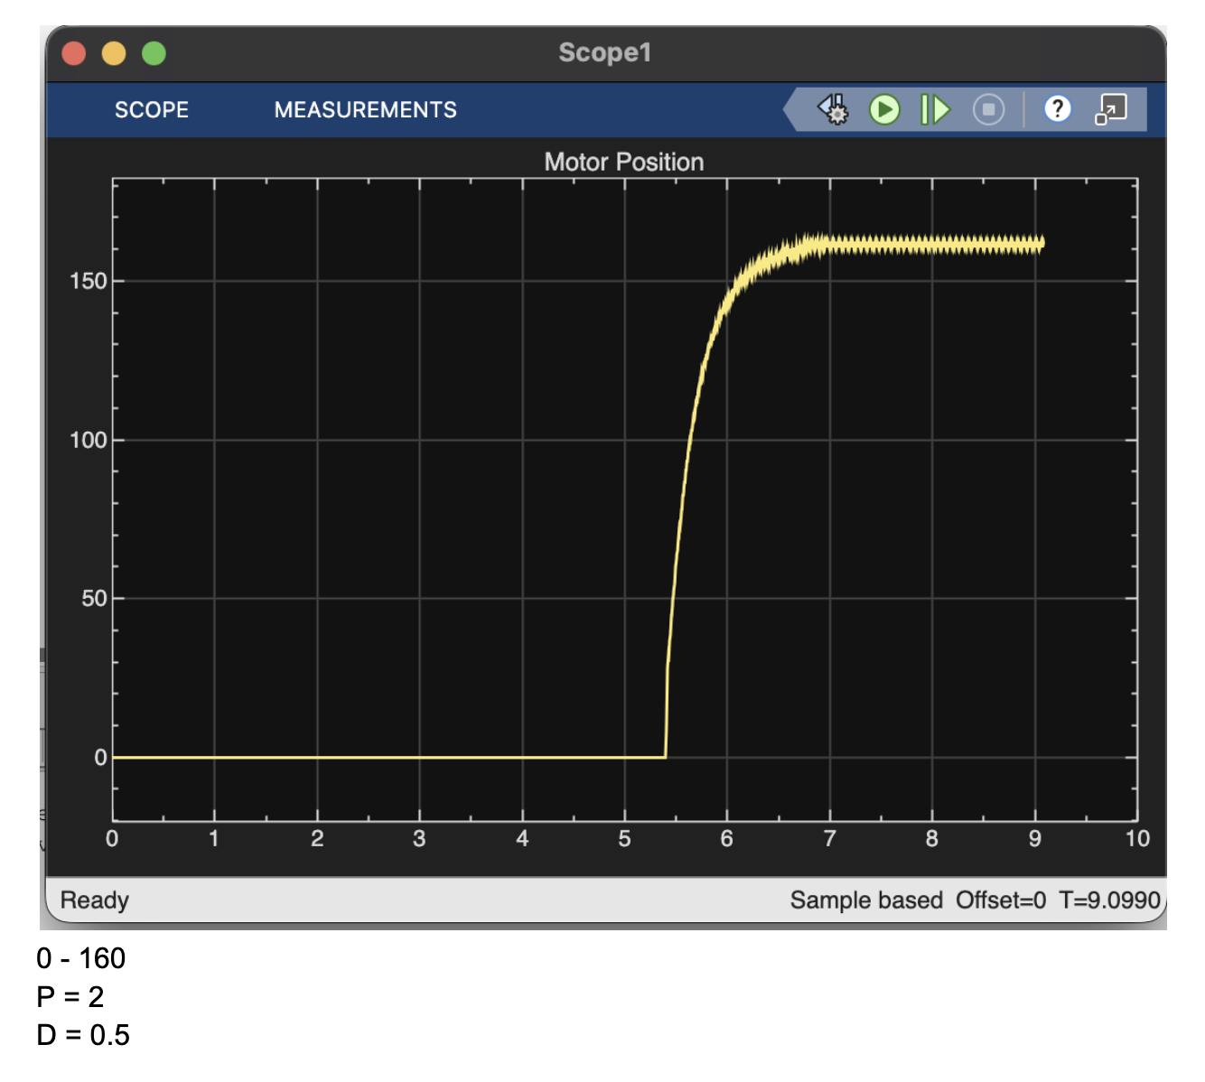
Figure 6: Motor angle response for Kp = 2 and Kd = 0.5
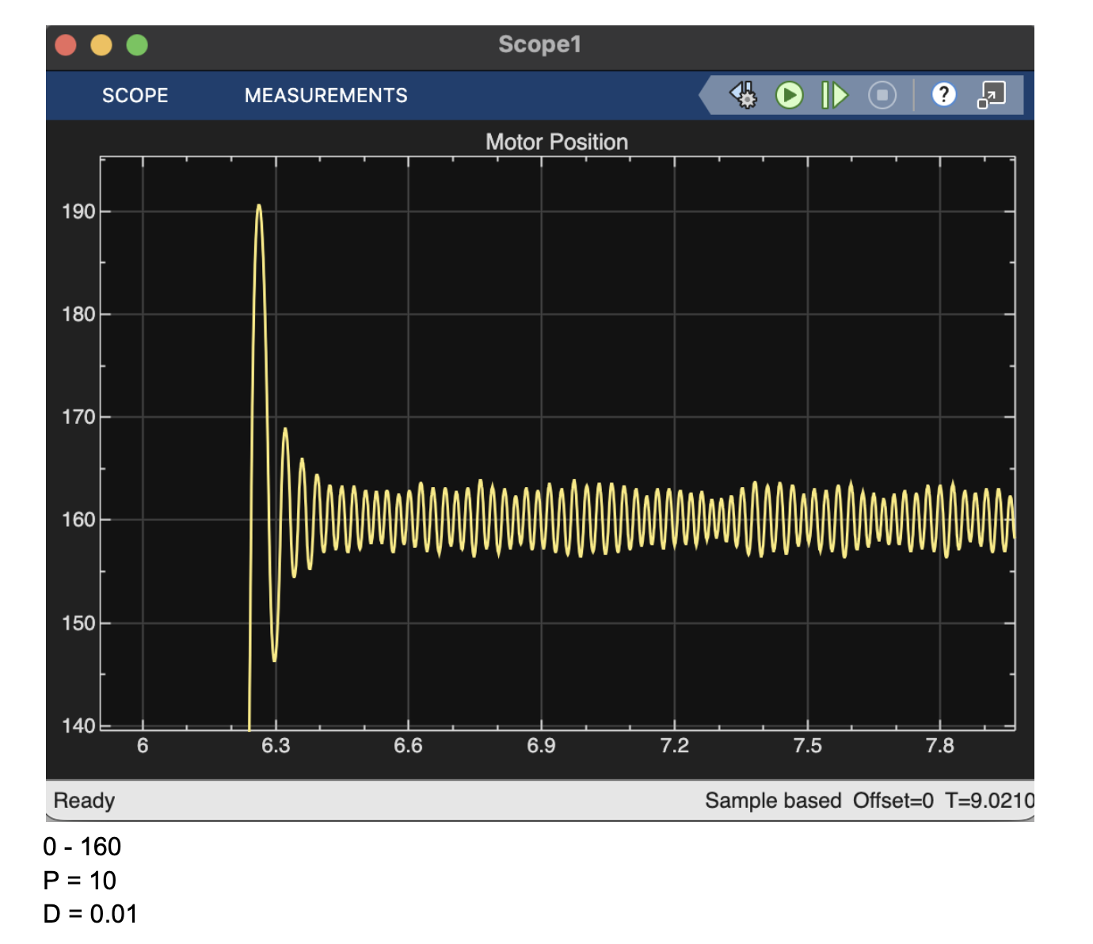
Figure 7: Motor angle response for Kp = 10 and Kd = 0.01

When moving the motor to the target, the ‘reference’ is the X position where the arrow should be, the “actual” is the current position of the arrow, and the ‘proportional’ knob is adjusted to change the speed from the base state to the X position. If this setting is too high, the arrow may arrive at the target too quickly and then overshoot, requiring readjustment. This scenario can be seen in Figure 7. Because the proportional constant is set too high, the signal overshoots and never properly settles. This is where the ‘derivative’ knob comes into play. Adjusting this value adjusts the speed as the arrow gets closer to the target, almost like tapping the brakes when you approach the target, so the arrow doesn’t zoom past the target or get stuck in a bouncing motion. The derivative thus makes the motion smoother and cuts the wiggle. Figures 5 and 6 show these scenarios where the derivative gain slows down the wave form. In the case of Figure 6, the waveform is still unstable and needs a lower proportional gain in order to settle properly. Figure 5 shows the case where both the proportional gain and the derivative gain are perfect, leading to a quick and efficient motor angle response without any overshoot. For our motor purposes, this will be the configuration we use in our project.

User Interface Documentation and Evaluation

To seamlessly interact with the user, we decided to develop a GUI that overlays interactive buttons on a picture taken by the game board's camera. This way, the user can visually see which pin they are selecting and physically select the pin they want to point to. The buttons are coded such that when the user presses them, the location data associated with that pin is passed to the motor mover function, which then points the motor to the desired position. Figure 8 below shows an example of the GUI that the user interacts with when the program is run, including the option to advance background acquisition and the selection of an object.
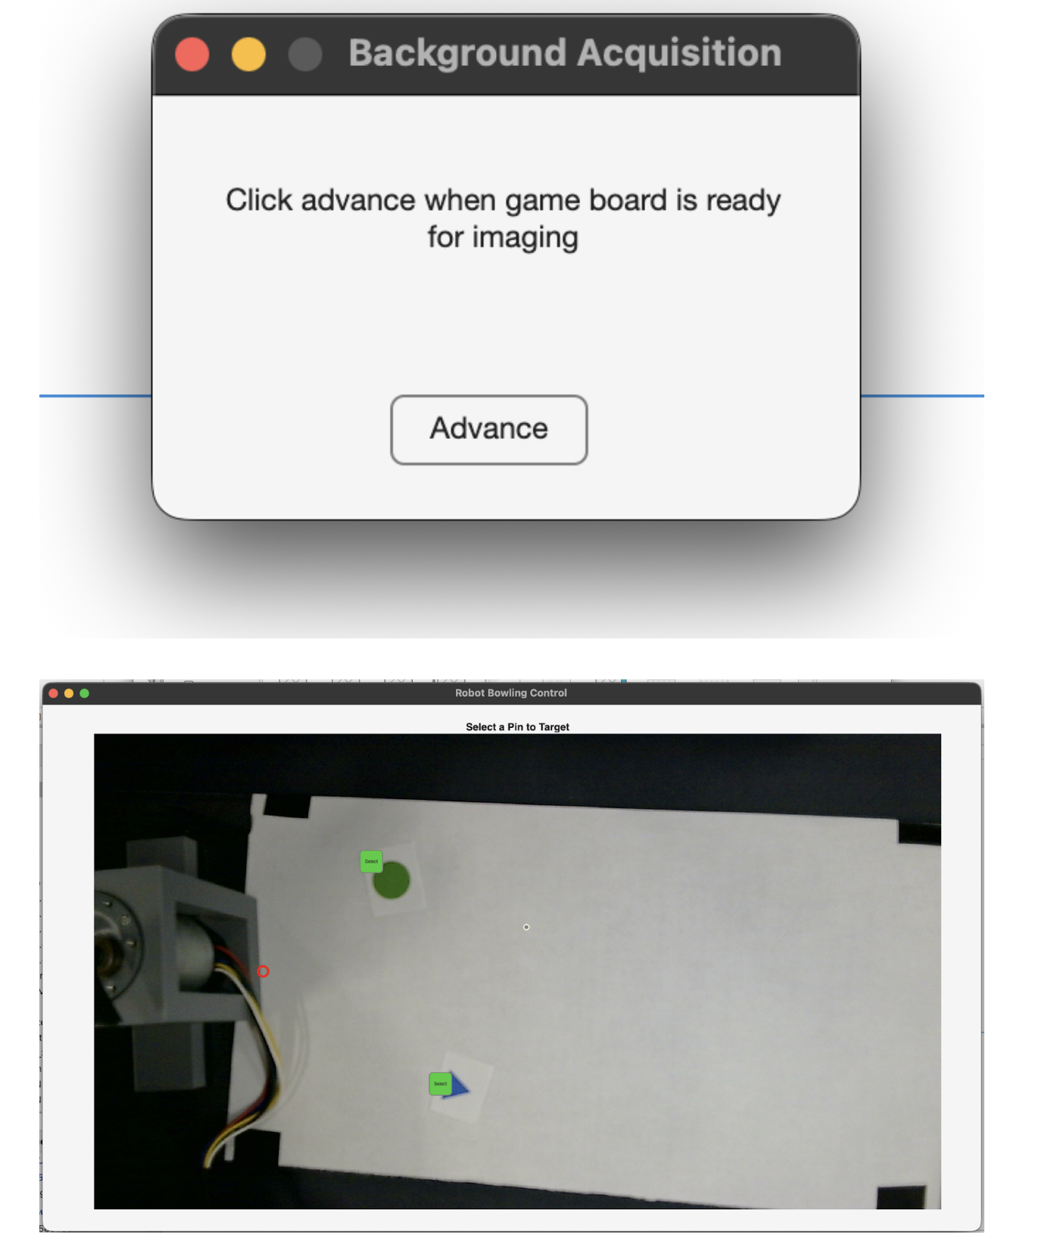
Figure 8. Pin Selection GUI

As we can see, the GUI is easily interpretable and simple to interact with. The only information the user needs to make a decision is the picture of the game board that contains all the pins. All they need to do after deciding which pin to choose is to click the corresponding button. In addition to the pin selection GUI, the program utilizes two other user interface elements. At the beginning of the program, two dialog boxes are displayed, which hold the program until the user has properly set up the game space for the background and foreground images. This allows the user to take their time setting up the game board, increasing user-friendliness.

Life Cycle Analysis

For this part of the lab, we utilized the BEES (Building for Environmental and Economic Sustainability) software to conduct a hypothetical life cycle assessment (LCA) comparing two potential materials for the robot’s shipping and storage box: aluminum siding and vinyl siding. The goal was to determine which material would have the lowest environmental impact while remaining cost-effective.
In BEES, we compared the two siding types across all life-cycle stages, including raw materials, manufacturing, transportation, use, and end-of-life. The program then produced several graphs showing environmental performance, global warming potential, embodied energy, and economic performance. Overall, vinyl siding came out as the better option in nearly every category.
In the Environmental Performance graph (Figure 9), vinyl siding scored a total of 0.0018 points per unit, while aluminum scored 0.0026 points per unit (lower is better). Most of the difference comes from the raw material stage. Manufacturing also contributes slightly more for aluminum, but the impacts of transportation, use, and disposal were not as significant.
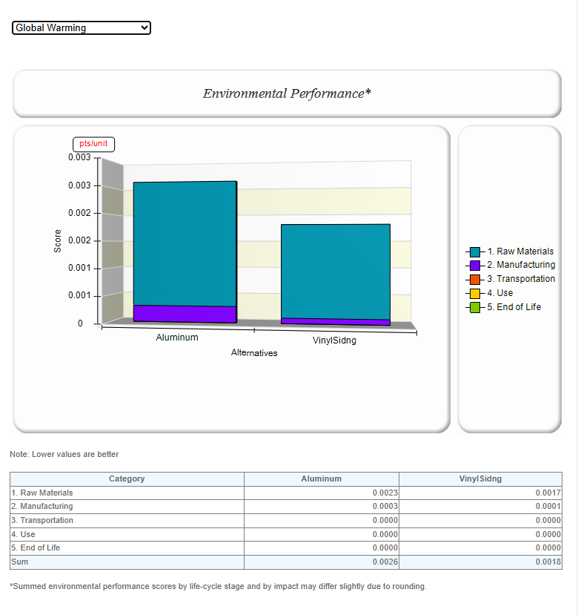
Figure 9. Environmental Performance Graph
For the global warming analysis, the BEES software breaks down each material’s total greenhouse gas emissions in grams of CO₂ equivalent per unit of siding. The results show that aluminum siding has a total score of approximately 1,538 g CO₂ per Unit, while vinyl siding has a significantly lower score of approximately 654 g CO₂ per Unit. Since lower values represent a smaller carbon footprint, vinyl siding clearly performs better in this category.
Most of aluminum’s emissions come from fossil carbon dioxide (about 1004 g CO₂), carbon tetrafluoride (298 g CO₂), and CFC 12 (175 g CO₂). Vinyl siding’s emissions are dominated by fossil CO₂ (565 g CO₂), but its use of industrial greenhouse gases is significantly lower across the board (Figure 9). The main takeaway is that aluminum production releases over twice as many greenhouse gases per unit compared to vinyl siding. Vinyl siding, being lighter and less energy-intensive to produce, results in a smaller carbon footprint.
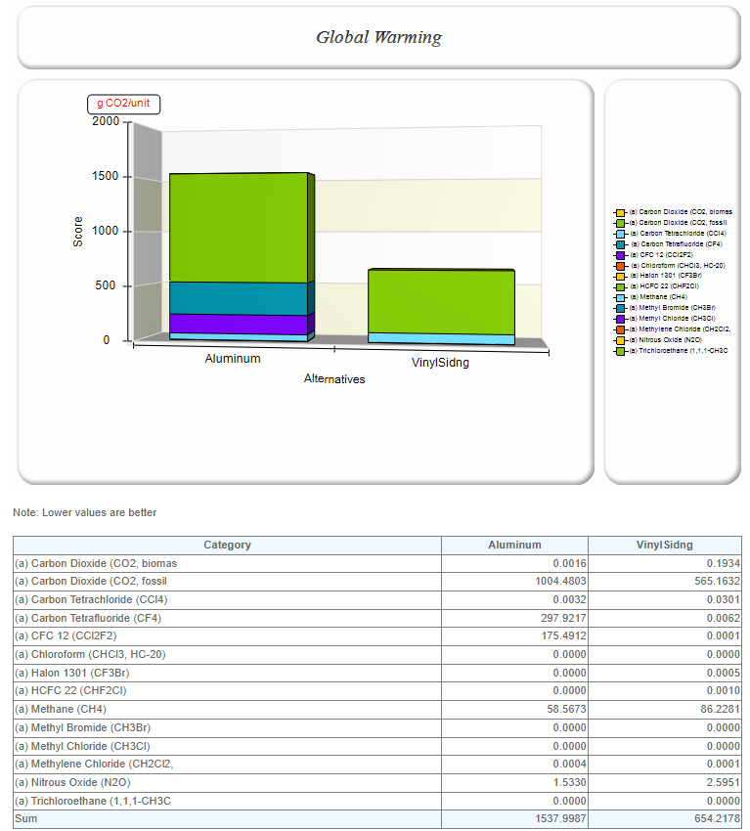
Figure 10. Global Warming Graph
The Embodied Energy results (Figure 10) indicate that aluminum siding requires approximately 12.6 MJ/unit, while vinyl siding requires 12.3 MJ/unit. Although the totals are similar, aluminum relies more heavily on fuel energy (approximately 12.1 MJ), while vinyl uses more feedstock energy (about 4.1 MJ).
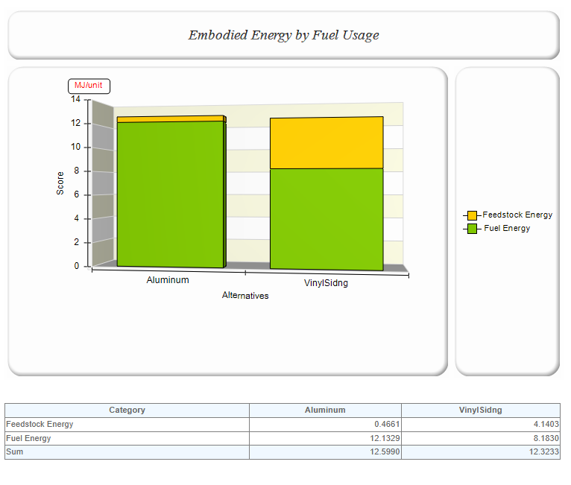
Figure 11. Embodied Energy Graph
Finally, the Economic Performance data (Figure 11) showed that vinyl siding is also slightly less expensive overall. Aluminum had a total cost score of 2.75 PV$/unit, compared to 2.56 PV$/unit for vinyl. The difference mostly comes from the first cost; aluminum’s initial manufacturing and installation costs are higher, while both materials have similar long-term costs.
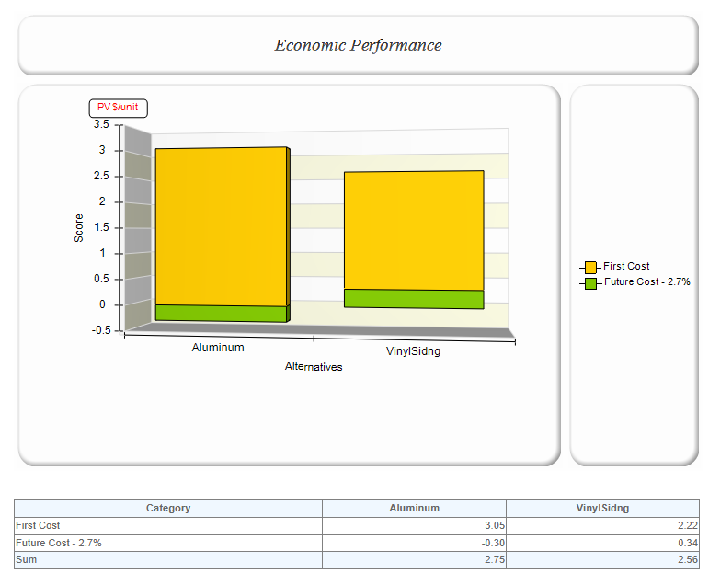
Figure 12. Economic Performance Graph
Overall, the results show that vinyl siding is the better choice for the robot’s shipping box. It performs better environmentally, produces fewer greenhouse gas emissions, requires slightly less total energy, and costs less to manufacture. The biggest takeaway is that the largest environmental impacts arise from the raw material and manufacturing stages, rather than transportation or disposal. This means that if we wanted to further reduce the overall footprint of the robot, focusing on material selection and production efficiency would have the greatest effect.
This same type of life-cycle analysis could also be applied to the rest of the robot’s design. By running similar comparisons for all the components, we could identify which have the highest environmental impact and look for ways to reduce them.

Financial Analysis
For this part of the lab, we calculated the first year financial analysis for a hypothetical startup, Robo-Tek Engineering, a fifteen-engineer firm based in Greenville, South Carolina. The company also includes one president and one administrative assistant. All calculations were derived from the provided financial model and adjusted to reflect Greenville’s typical lease rates and cost of living.
Personnel expenses make up the majority of the budget. With each engineer earning $55,000 annually, along with the president earning $75,000 and the administrative assistant earning $25,000, the total salaries amount to $ 155,000. Applying a 32 percent fringe benefit rate adds another $296,000, covering FICA, insurance, and retirement. As a result, total personnel costs amount to approximately $1.22 million. The firm requires 1,904 square feet of office space, leased at $0.79 per square foot per month, resulting in an annual building cost of about $18,050. Furniture, computers, software, and other office equipment add $81,223, while phone and internet services total $19,992 per year. Travel expenses, including two local and two national trips per month, are estimated at $76,800 annually. To fund startup purchases, a $950,000 loan at 5% interest yields approximately $88,737 in monthly payments (1) and $26,105 in first-year interest payments (2). Altogether, the company’s total annual expenses amount to approximately $1,443,170.
Assuming each engineer is billable 75 percent of the time, total billable labor equals $618,750, and fringe benefits add another $198,000. The remaining non-billable expenses, or overhead, amount to $626,420, yielding an overhead rate of 76.7 percent. This means that every dollar of direct labor must be increased by approximately $0.77 to cover indirect operating costs. Including a five percent profit margin results in a total multiplier of 1.82. Therefore, one week of an engineer’s work, costing approximately $1,396 with benefits, should be billed to clients at around $2,590 (3).
Equations:
Loan monthly payment: (1)
$Monthly payment = Principal amount∗\frac{(\frac{Interest rate}{\# of payments to be made})(1+\frac{Interest rate}{\# of payments to be made})^{(\# of payments to be made)}}{(1+\frac{Interest rate}{\# of payments to be made})^{(\# of payments to be made)} -1}$
$= (\$950,00)⋆\frac{(\frac{5\%}{11})(1+\frac{5\%}{11})^{(11)}}{(1+\frac{5\%}{11})^{(11)}-1}= \$88,737$
Total interest paid in year: (2)
$Debt Service = 11∗ Monthly payment - Principal amount$
$= 11 ∗ \$88,737 - \$950,000 = \$26,105$
Labor cost with overhead rate: (3)
$Labor cost = salary + fringe$
$= (\frac{\$55,000}{4})+ (\frac{\$55,000}{4})∗32\%=\$1,396$
$Cost client is billed = 2∗(Labor cost)∗(1+\frac{ Overhead Rate}{100})+5\% profit$
$=2∗ \$1,396∗(1+\frac{76.7\%}{100\%})∗0.05\%=2590.30$

Employee Training Program
To maintain and enhance the technical and managerial skills of our newly graduated engineers, our start-up will implement a one-year training program that focuses on professional development, technical expertise, and staying current with rapidly changing industry standards. We expect each employee to dedicate approximately 60 hours per year to developing professional and technical skills. We have allocated around $7,000 to provide our employees with quality experiences that will enable them to develop their skill set. This investment supports long-term productivity, retention and innovation by keeping employees current with rapidly changing engineering practices.

Archetype 1: Newly Graduated Technical Engineer (Problem Solver)

Activity | Benefit | Cost
Online NEC Course | Provides up-to-date knowledge on rapidly changing safety standards. Ensure that the Engineer’s work aligns with National Safety Code compliance as well as legal standards. | Training Package = 329$  Employee time = $40*10 = 400$  Total = 720$
SKM Training | Hands-on Experience with power management software enables in-house analysis of Arc Flash, Short Circuit, and Breaker events. Critical for electrical system reliability | 5 Day in-person course = $2446  Flight = $300  Hotel = $1000  Food = $300  Employee time= $40*40 = $1600  Total = $5646
Attend IEEE Southeast Conference | Network with other engineers involved in different or similar industries. Learn about new cutting-edge technology becoming available | Free Entry with Membership  $109/yr  Flight = $100  Hotel = $100  Employee time 40*16 = $320  Total = Approx $500

Archetype 2: Newly Graduated Project Management Engineer (Technical Manager)

Activity | Benefit | Cost
IEEE Technology and Engineering Management Society Membership | Open access to IEEE project management resources, technical leadership material, and global networking opportunities | Membership = 109/year  Total $109
Attend Online Project Management Seminar | Introduces new methodologies such as within the scope of communication and leadership. Gain confidence and new strategies for group management. | Course cost = $299  Employee time = 40$ * 16 + $640  Total = 959$
In-Person AEC Project Management Bootcamp | Employees will attend boot camp to learn how to maximize profitability, project success, and methods to strengthen client relationships, as well as explore new revenue opportunities. This bootcamp is from an accredited institution with over 20 years of experience in engineering management | Course cost = $2495  Flight = $100  Hotel = $300  Food = $100  Employee time= $40*16 = $640  Total = $3535

Across both archetypes, this program ensures that all engineers build a strong foundation of practical skills, compliance and professional growth. These activities enhance our start-up's capability to execute complex engineering projects safely, efficiently, and collaboratively, while keeping employees engaged in lifelong learning, with the added benefits of membership in electrical engineering institutions.

Safety Analysis

Subsystem / Function | Failure Mode | Potential Effect(s) | Potential Cause(s) | Severity (I–IV) | Likelihood (A–E) | Risk Index (Cell)
Ramp body (PLA) | Cracks/delamination under impact | Ramp deforms; ball trajectory unpredictable | Layer orientation weak; low infill; cold print | II | D | II-D
V-groove ball track | Ball jams or rides wall | Unexpected angle; stall | Too narrow/rough; warpage | III | C | III-C
Guard rails / lip | Premature exit | Ball leaves lane; bystander strike | Rail too low/misaligned | II | D | II-D
Linear guide rods | Binding or play | Mis-mesh; stall | Holes off; rods not parallel | III | C | III-C
Rack & pinion mesh | Tooth skip/wear | Loss of position | Backlash; poor mesh height | III | C | III-C
Gearmotor mounting | Motor loosens/shifts | Disengagement; projectile | Short screws; no threadlocker | II | D | II-D
12 V power path | Short/overheat | Burn/smoke; damage | Loose terminals; small wire | I | D | I-D
Control logic (Arduino) | Uncommanded motion | Pinch at end stop; damage | Bug; missing bounds; encoder glitch | II | D | II-D
End stops | Over-travel | Rack cracks; stall | Brittle/absent | III | C | III-C
Operator interaction (pinch) | Fingers near mesh | Pinch/laceration | No guard; curiosity | III | D | III-D
Table 2. DFMEA Table

Before finalizing the design, we performed a safety analysis to make sure the system could be used safely and consistently at our workstation. We did a Design Failure Mode and Effects Analysis (DFMEA), which helped us realize possible failures across the mechanical, electrical, and control subsystems. Each potential failure was analyzed for its severity, likelihood, and impact.
The DFMEA table summarizes these findings (Table 2). For example, we realized the ramp body was a possible weak point due to print orientation and infill density, which could cause wear and cracking under repeated impacts. To prevent this, the print was reinforced with more perimeters. Many of the mechanical hazards, like finger pinching or the ball leaving the ramp, were mitigated with printed covers, guard rails, and testing procedures.

 | Likelihood
Severity | A (Very Probable) | B (Probable) | C (Occasional) | D (Remote) | E (Improbable)
I Catastrophic | IA | IB | IC | ID | IE
II Critical | IIA | IIB | IIC | IID | IIE
III Marginal | IIIA | IIIB | IIIC | IIID | IIIE
IV Negligible | IVA | IVB | IVC | IVD | IVE
Table 3. Risk Assessment Matrix

A risk assessment matrix (Table 3) was then used to categorize these issues based on their severity and probability. Most items initially fell into the Serious or Medium zones, but after some modifications to our design, nearly all risks were reduced to the Medium or Low categories. The remaining minor risks, like print imperfections or alignment shifts, are manageable with visual checks before each use.
Overall, these steps ensured that both the hardware and workspace remained safe for our group. We can confidently conclude that the system is safe for classroom and testing use.

References

[1] A. Abdulrahman and S. Varol, “A Review of Image Segmentation Using MATLAB Environment,” 2020 8th International Symposium on Digital Forensics and Security (ISDFS), Beirut, Lebanon, 2020, pp. 1–5, doi: 10.1109/ISDFS49300.2020.9116191.

[2] Logitech, “Brio 100 Full HD Webcam — Technical Specifications,” 2025. [Online]. Available: https://www.logitech.com/

[3] MathWorks, Image Processing Toolbox and Image Acquisition Toolbox Documentation, MATLAB R2025b, Natick, MA, USA, 2025. [Online]. Available: https://www.mathworks.com/help/

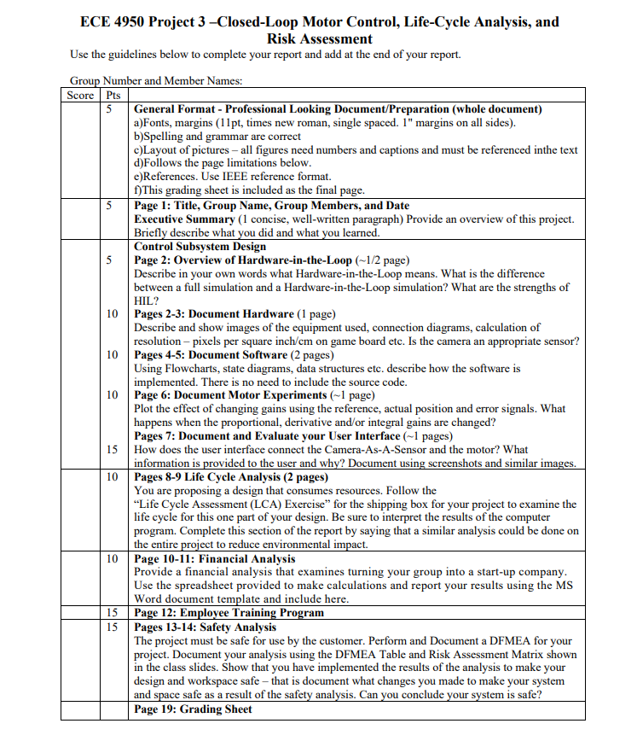
Link to slides: https://docs.google.com/presentation/d/1zeJx6oLBGX-HbdODhsWaSp4Q8Df2GWYNWd_ysWKzVQg/edit?usp=sharing

Link to website:
https://sites.google.com/g.clemson.edu/team19-thebiglebowski/home

